1. IAM
2. Security recommendations 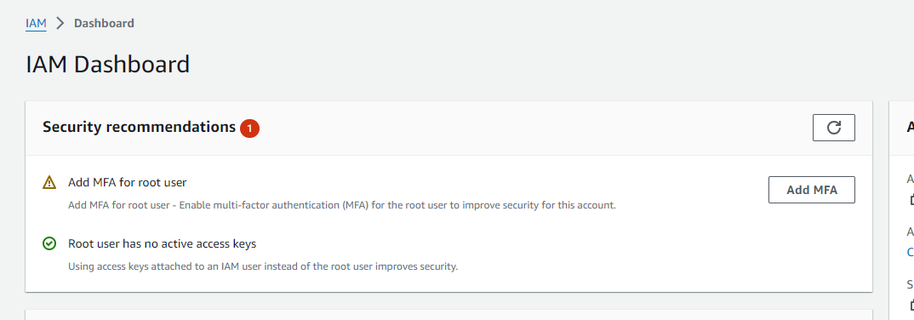
3. Select Authenticator App , Write Device Name  
   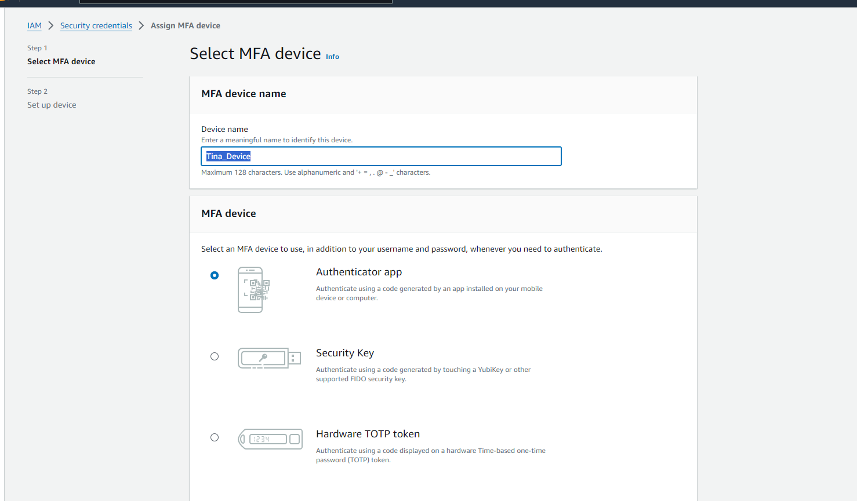
4. Install Google Authenticator
5. Show QR Code
6. Scan QR Code on your App  
   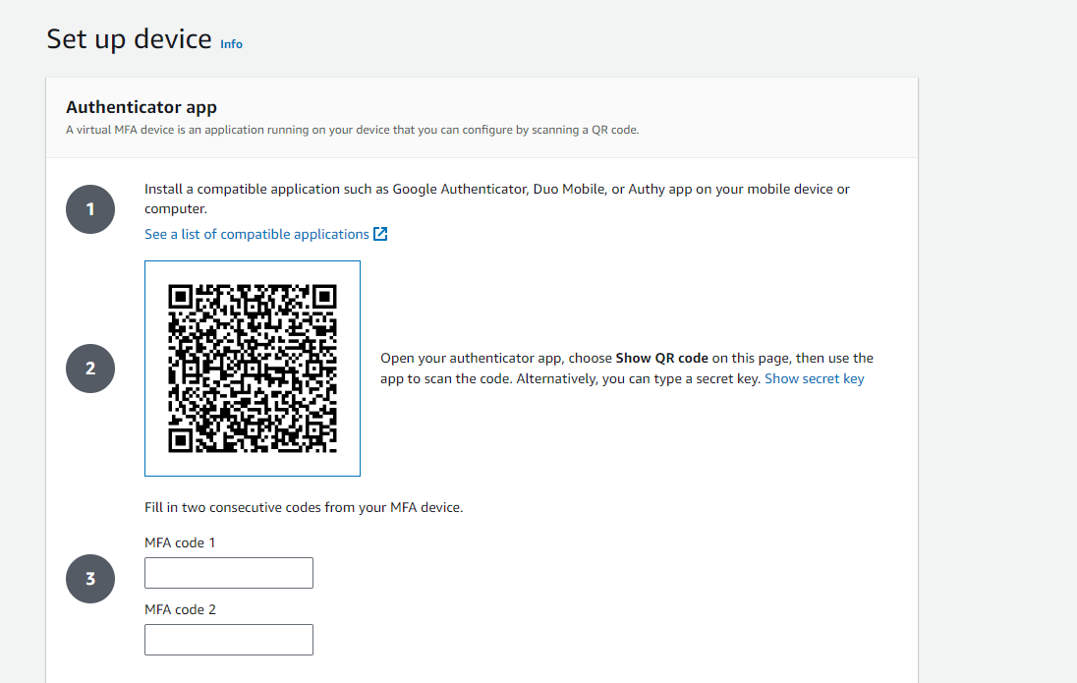
7. Enter 2 device codes and Add MFA (No Space)  
   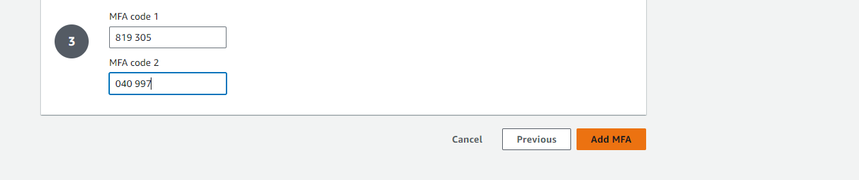
8. MFA Device has been assigned/added , it will redirect you to this page  
   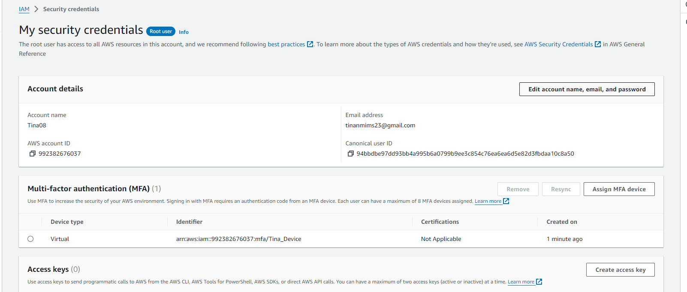
9. Logout and Login again
10. After entering credentials, it will ask for MFA Code  
    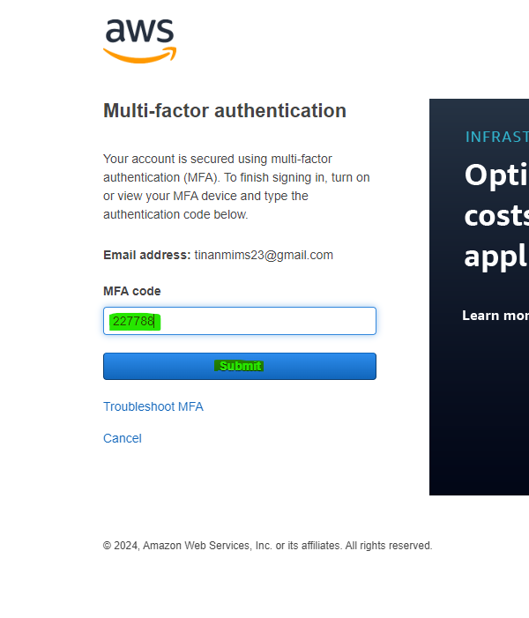
11. Submit and Login
12. Create a New User, Give Security Access to User  
    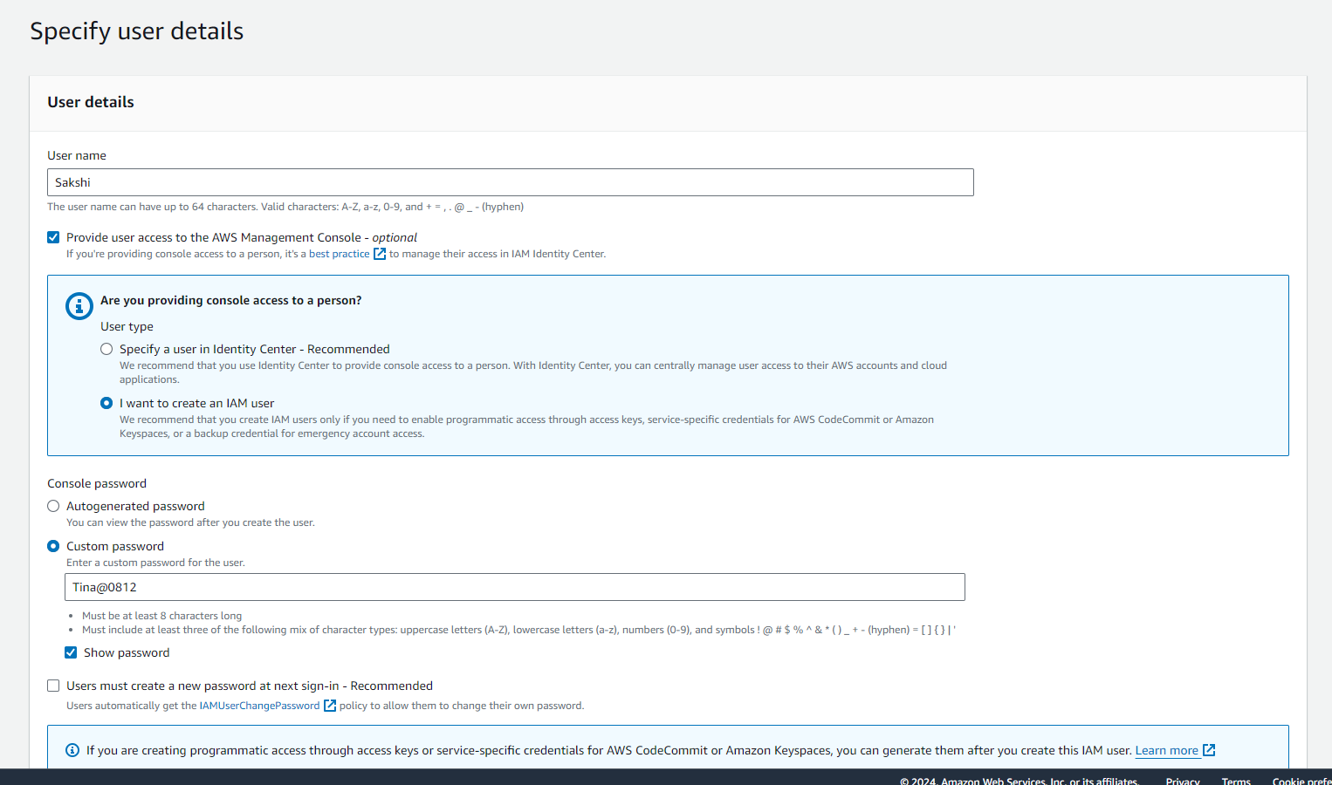
13. Give any Policy Access to the User  
    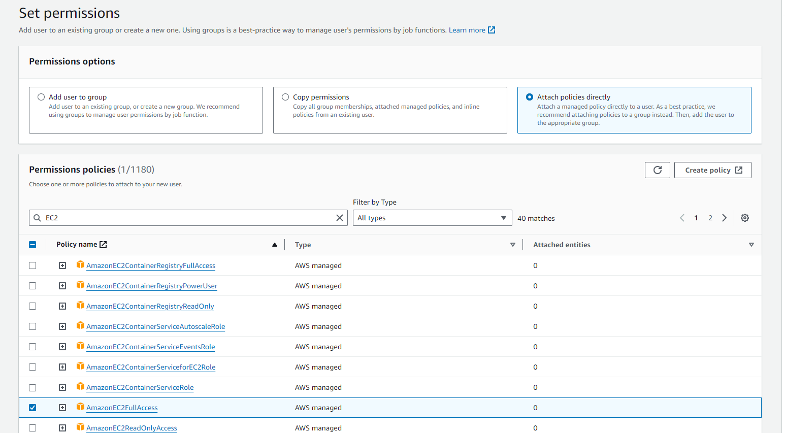
14. Create the User  
    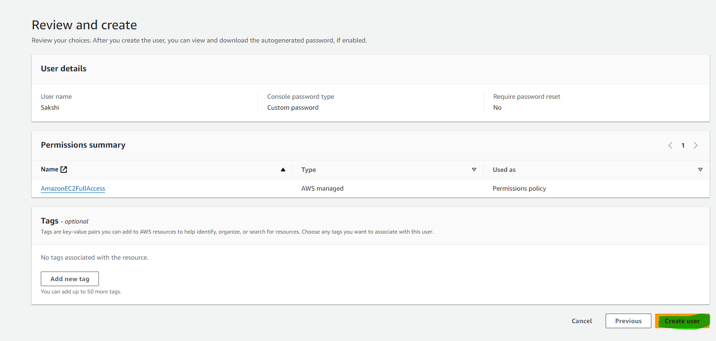
15. 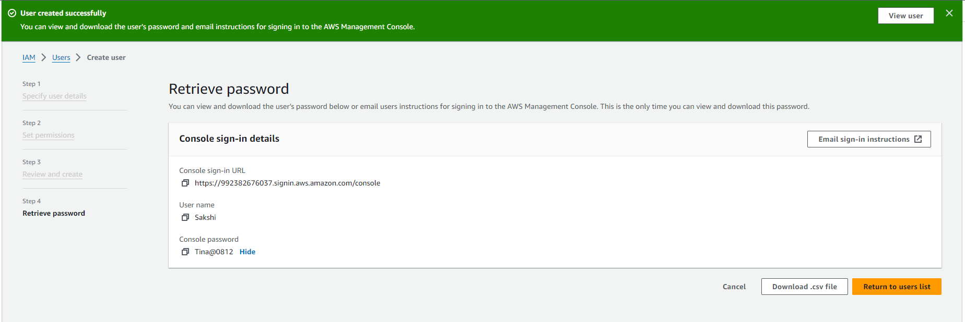
16. Click On Username -> Security Credentials  
    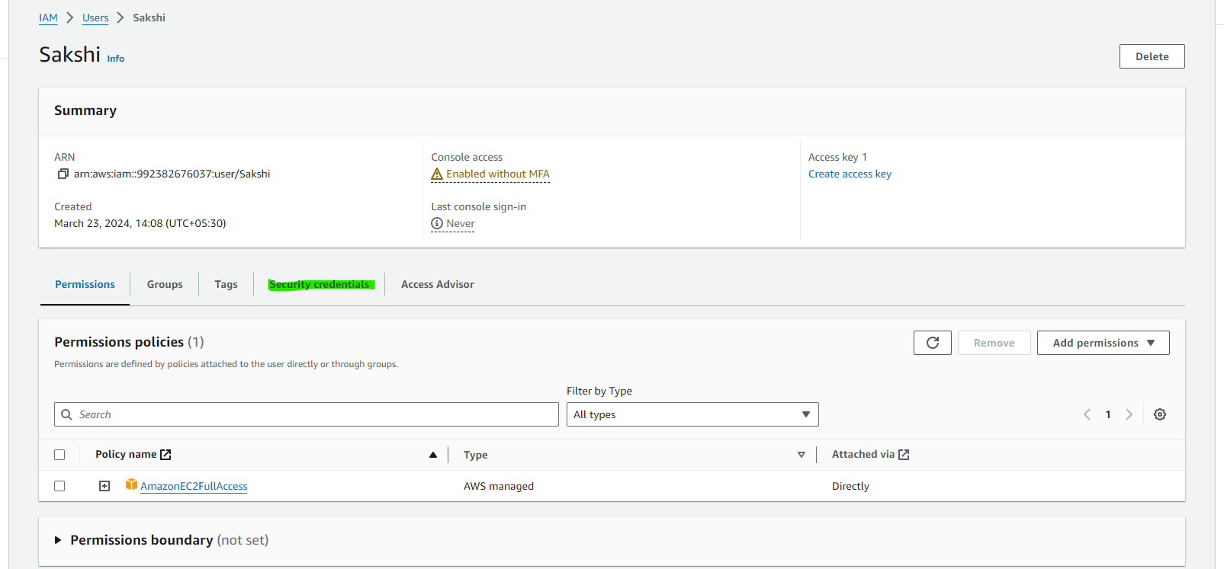
17. Assign MFA Device  
    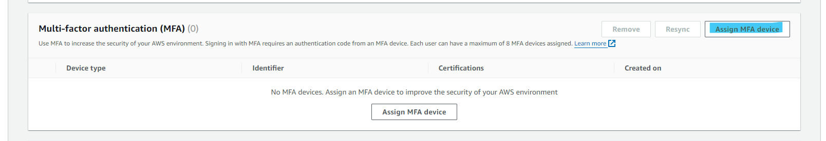
18. Show QR Code
19. Select Authenticator App , Write Device Name  
    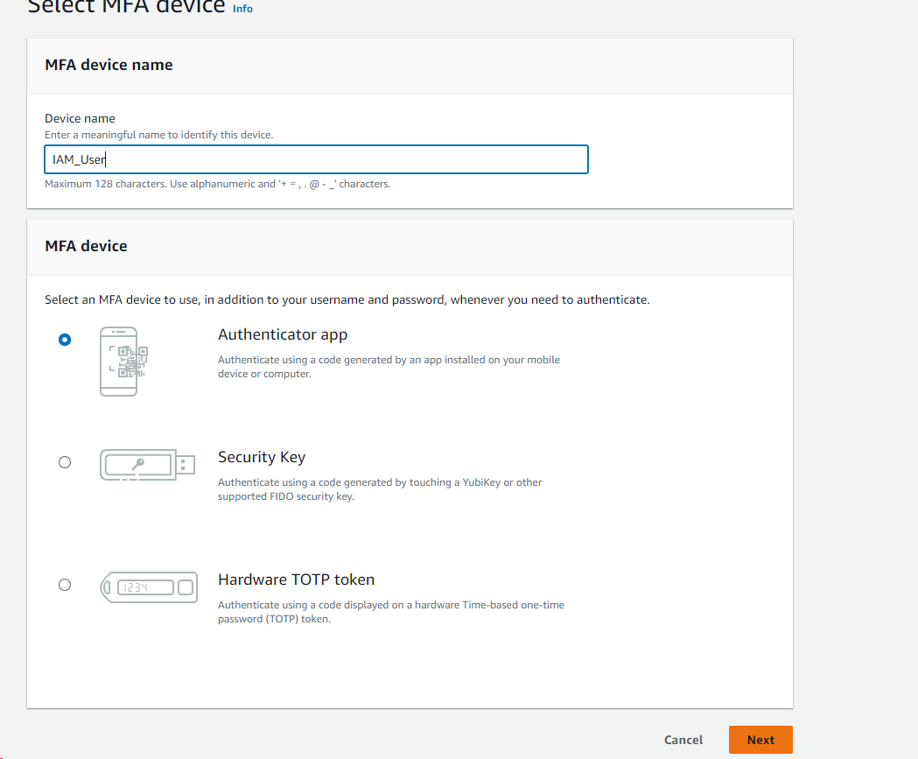
20. Show QR code -> Scan QR Code on your App  
    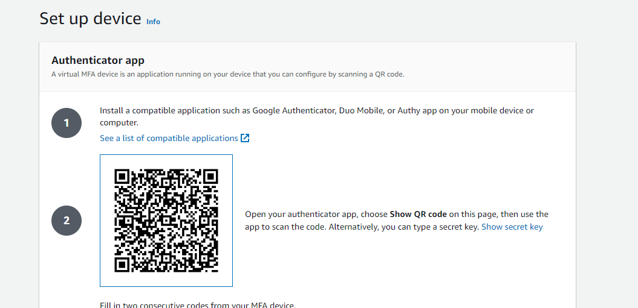
21. Enter 2 device codes and Add MFA (No Space)  
    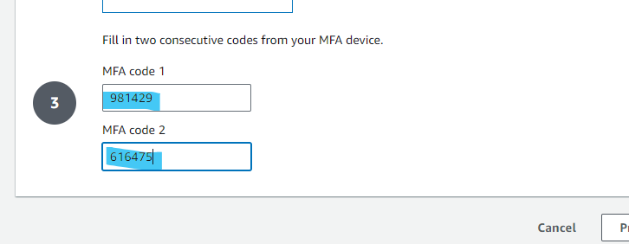
22. MFA Device has been assigned/added , it will redirect you to this page  
    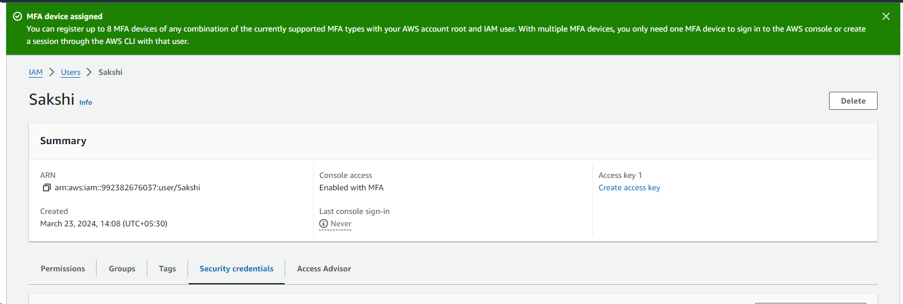
23. Logout .